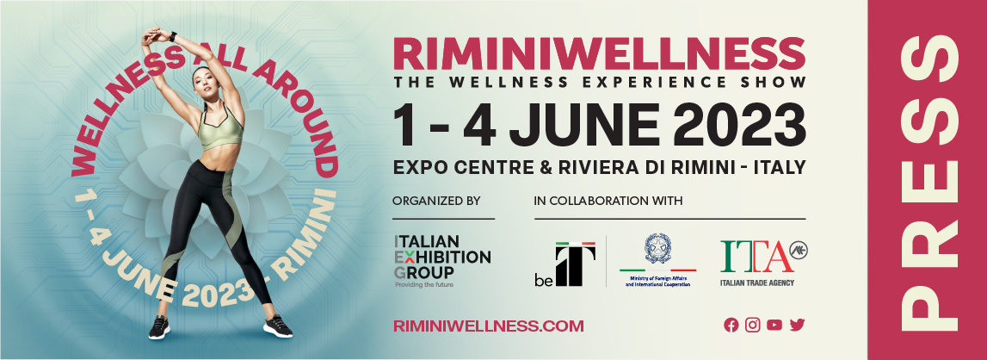

press release
(English translation)

ITALY AND RIMINIWELLNESS 2023 WELCOME HYROX

- The discipline that is revolutionising the fitness world, for the first time in Italy at the Italian Exhibition Group event
- HYROX is suitable for everyone, from beginners to professionals, thanks to an exclusive format and 4 levels of competition
- Training is a unique mix of running and functional workouts

Rimini (Italy), 14th March 2023 - The 17th edition of RiminiWellness will not cease to amaze and confirms its role as a veritable hub brimming with high-adrenaline new entries. In fact, this year the IEG - Italian Exhibition Group event, scheduled to take place from 1st to 4th June 2023 at the Expo Centre and on the Riviera, will host Italy’s grand debut of HYROX, the new sports discipline that is revolutionising the fitness world.

Designed for both inexperienced and professional athletes, HYROX is an international competition that perfectly combines strength, endurance and determination. The competition - to be held during RiminiWellness on Friday 2nd and Saturday 3rd June - has a unique format, accessible to anyone, regardless of their fitness level. It starts with a one-kilometre run, followed by a functional workout, the whole thing repeated 8 times and held in a large indoor space, creating an engaging atmosphere for all participants. The exercises are a mix of functional workouts that alternate during the competition: from SkiErg, Sled Push, Sled Pull, Burpee Broad Jumps, Rowing, Farmers Carry, Sandbag Lunges and Wall Balls.

Every athlete has just one goal: to complete the same course in time and in accordance with their starting level. In fact, in order to be within everyone's reach, HYROX offers 4 different race categories to choose from: Open, for a challenging but accessible competition; Pro, for real professionals with the use of heavier weights; Double, to take on the challenge in pairs, running together and sharing the workload of the exercises; and lastly, Relay, designed to involve friends and training partners.
For further information on this new discipline and how to register, go to the following website: https://en.riminiwellness.com/events/special-event/hyrox

ABOUT RIMINIWELLNESS 2023
Dates: 1-4 June 2023; event: international trade show; organization: Italian Exhibition Group S.p.A.; frequency: annual; edition: 17th; entry: public and trade; info: www.riminiwellness.com

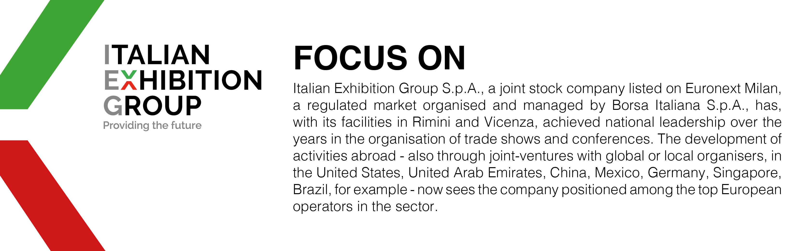

PRESS CONTACT ITALIAN EXHIBITION GROUP
head of corporate communication & media relation: Elisabetta Vitali |
press office manager: Marco Forcellini | press office specialist: Luca Paganin |
international press office coordinator: Silvia Giorgi |
media@iegexpo.it

MEDIA AGENCY RIMINIWELLNESS
Naper Multimedia| Zoe Perna | T. +39 02 97699600 | staff@napermultimedia.it

This press release contains forecast elements and estimates that reflect the management’s current opinions (“forward-looking statements”), particularly regarding future management performance, realization of investments, cash flow trends and the evolution of the financial structure. For their very nature, forward-looking statements have a component of risk and uncertainty, as they depend on the occurrence of future events. The effective results may differ (even significantly) from those announced, due to numerous factors, including, only by way of example: food service market and tourist flow trends in Italy, gold and jewellery market trends, green economy market trends; the evolution of raw material prices; general macroeconomic conditions; geopolitical factors and evolutions in the legislative framework. Moreover, the information contained in this release, does not claim to be complete, and has not been verified by independent third parties. Forecasts, estimates and objectives contained herein are based on the information available to the Company as at the date of this release.

